CC3501 Weekly Report

**Group number:** 2 **Team members:** Ethan Waters, Lachlan Pryce  
**Week number:** 7

**Progress this week**

|  |  |  |  |  |
| --- | --- | --- | --- | --- |
| **Task** | **Who did it?** | **What were the outcomes?** | **Who did the peer review?** | **What did you learn?** |
| Check logical output voltage levels for all CAN bus hardware | Ethan | Corrected CAN bus | Lachlan | Can not assume logical output voltages are 3V3 |
|  |  |  |  |  |
|  |  |  |  |  |
|  |  |  |  |  |
|  |  |  |  |  |
|  |  |  |  |  |
|  |  |  |  |  |
|  |  |  |  |  |

**Overall project tracking:** [fill this in at the beginning of the project and update weekly based on actual progress]

|  |  |
| --- | --- |
| **Week number** | **Milestones** |
| 1 | Confirm project topic and begin |
| 2 |  |
| 3 | Arm can move with an input from a socket. The input is an automated test script executed by a client to mimic the embedded system output |
| 4 | Select components & review datasheets |
| 5 | Begin schematic |
| 6 | Complete Schematic, forward to Bronson for feedback. |
| 7 | Submit complete schematic to Bronson for feedback. Complete PCB design for feedback, |
| 8 | Submit board for manufacture. |
| 9 | Work on vision based movement with PI while waiting for embedded systems | Any other code that can be done before |
| LR |  |
| 10 |  |
| 11 |  |
| 12 |  |
| 13 | Demo day during Friday lab |

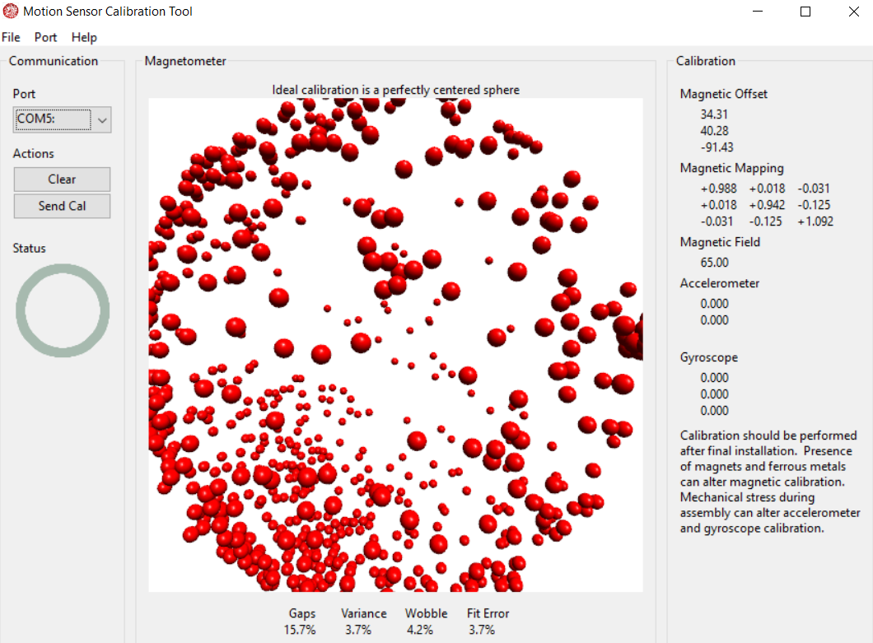

Figure 1: Magnetic offset values provided by MotionCal software. Calibration is achieved by manoeuvring IMU until enough data is recorded.